S3 Physics
Density and Kinetic Theory
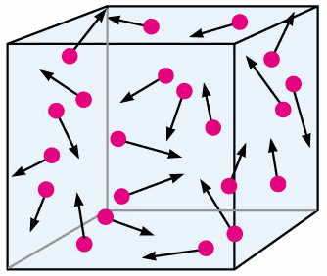

OUTCOME Booklet

- Learning Outcomes

SCN 4-08b
Through experimentation, I can explain floating and sinking in terms of the relative densities of different materials

SCN 4-05a
I have developed my understanding of the kinetic model of a gas. I can describe the qualitative relationships between pressure, volume and temperature of gases.

How Confident am I with the Content Statements?
- Circle the symbols to keep a record of your progress.
I am confident that I understand this and I can apply this to problems
I have some understanding but I need to revise this some more
I don’t know this or I need help because I don’t understand it

- You can use this to help you pick the areas of the unit that need the most revision.
- As you revise your class work you will be able to circle more and more smiley faces.
- If that does not help then you should ask your teacher!

Content Statements | Can you do this? | Comments
Density
1 To be able to explain, by looking at their densities, whether an object will float or sink in various liquids.
2 State that density is mass per unit volume of a substance.
3 To state that the units of density are grams per cubic centimeter (g/cm³).
4 Use the formula density =mass/volume to calculate the density of various objects.
5 To know how to measure the volume of a regular shaped solid.
6 To be able to describe how to measure the density of a regular shaped object.
7 To know how to measure the volume of an irregular shaped object.
8 To be able to describe how to measure the density of an irregular shaped object.
9 To be able to describe how to measure the density of a liquid.
10 To explain why different liquids separate when added together.
Kinetic Theory
11 To be able to identify a solid, liquid or gas by looking at a drawing of their particle arrangements.
12 To state that The Kinetic Theory of Gases describes a gas as a large number of small particles, all of which are in constant, random motion.
13 To state that the Kinetic Theory helps explain properties of gases such as volume, temperature and pressure.
14 To state that the pressure of a gas is caused by the particles colliding with the walls of the container that it is in.
15 To state that the temperature of a gas depends on the kinetic energy of the gas particles.
16 To state that the unit of Pressure is Pascals.
17 To state that as the volume of a fixed mass of gas increases, the pressure decreases provided the temperature of the gas remains constant (Boyle’s Law).
18 To be able to explain, with the aid of a diagram, why as the volume of a gas increases the pressure decreases provided that temperature remains constant.
19 To be able to use an Excel Spreadsheet to draw a graph.
20 To state that as the temperature of a gas increases the pressure increases provided the volume of the gas remains constant and that this is known as Gay Lussac’s Law.
21 To be able to explain why as the temperature increases the pressure of a gas increases provided the volume remains constant.

22 To state that as the volume of a gas increases the temperature increases provided the pressure of the gas remains constant and that this is known as Charles’ Law.
23 To be able to explain why as the temperature of a gas increases its volume increases provided the pressure of the gas remains constant.

